# Industry Grade Project 1: (ABC Technologies)

Submission By: Ranjith Kuswaha

Mail: ranjith7singh@gmail.com

Project remote Repository: <https://github.com/Ranjith700/Edureka-Perdue-project.git>

## Task1: Integrating Git

**Git:** Git is free and open-source software for distributed version control, tracking changes in any set of files, usually used for coordinating work among programmers collaboratively developing source code during software development

1. Create new repository in GitHub and push the initial code to repository
2. https://github.com/Ranjith700/Edureka-Perdue-project
   1. Copy the industry grade repo from Edureka industry grade project section
   2. Go to directory and execute following commands
      1. *: ~$ git init*
      2. *: ~$ git add .*
      3. *: ~$ git commit -m “adding remote repo”*
   3. Configure git for the first time to github
   4. Execute following commands
      1. *: ~$ git config –global user.name “Ranjith700”*
      2. *: ~$ git config --global user.email “singhranjith098@gmail.com”*
      3. Creating a personal access token to access the github – *Personal access token (PAT) are an alternative to using passwords for authentication to GitHub when using the GitHub API or the command line.*
   5. Push local repo to GitHub
      1. *: ~$ git remote add origin https://github.com/Ranjith700/Edureka-Perdue-project*
      2. *: ~$ git push –set-upstream origin master*
   6. Go back to GitHub and see that the repository has been updated.

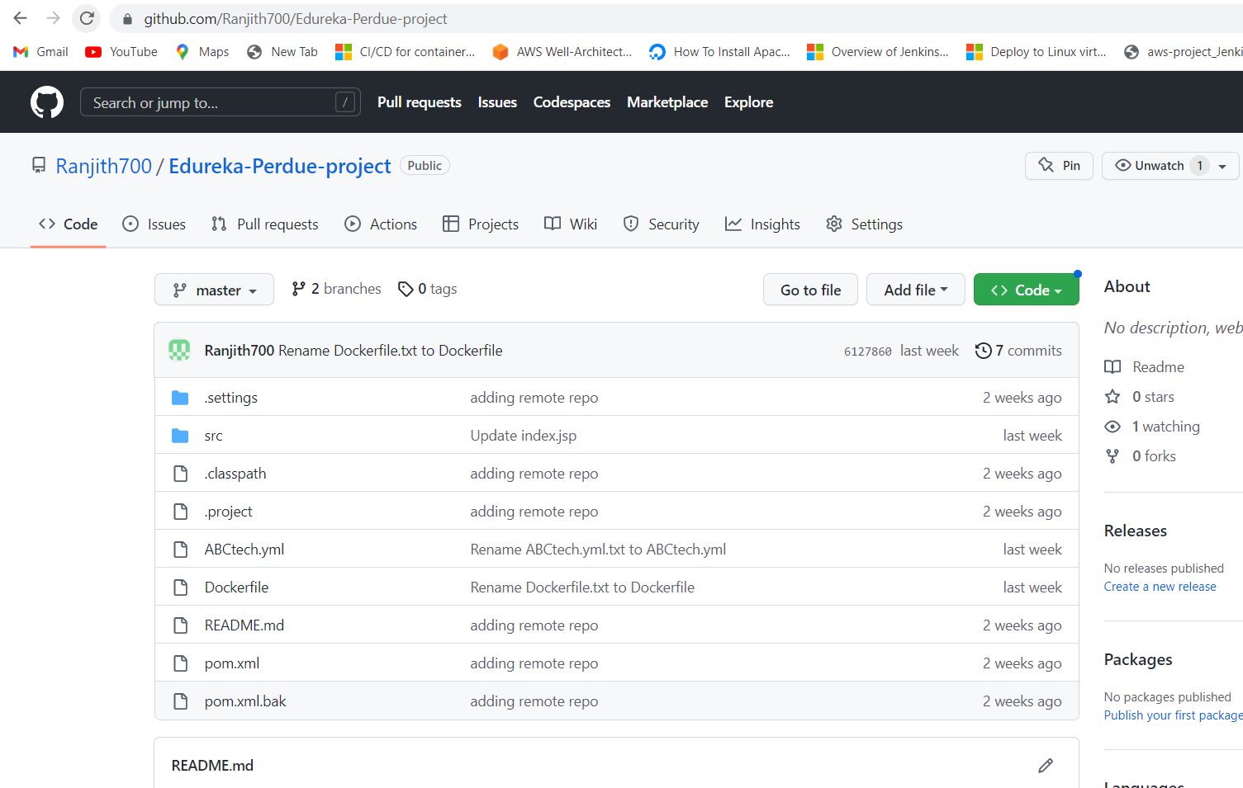

Setting up remote git repository

## Task 2: Integrating with Jenkins

**Jenkins:** Jenkins is an open-source automation server. It helps automate the parts of software development related to building, testing, and deploying, facilitating continuous integration and continuous delivery. It is a server-based system that runs in servlet containers such as Apache Tomcat and we can send and execute files/commands over SSH.

1. Installed Jenkins on Master node
2. Setup Jenkins on Master node
3. 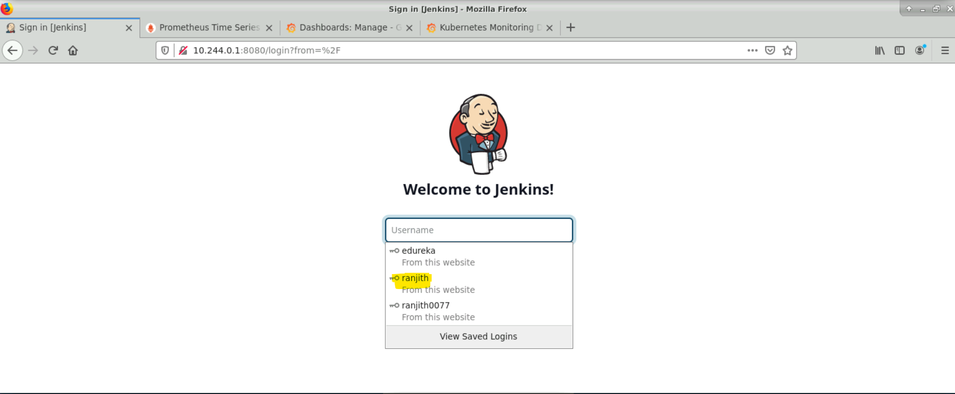
4. Login with ranjith user.
5. Installed required plugins (Git, Maven, Jacoco, Publish over SSH, etc)
6. Navigation: Dashboard >Manage Jenkins >Plugin Manager
7. 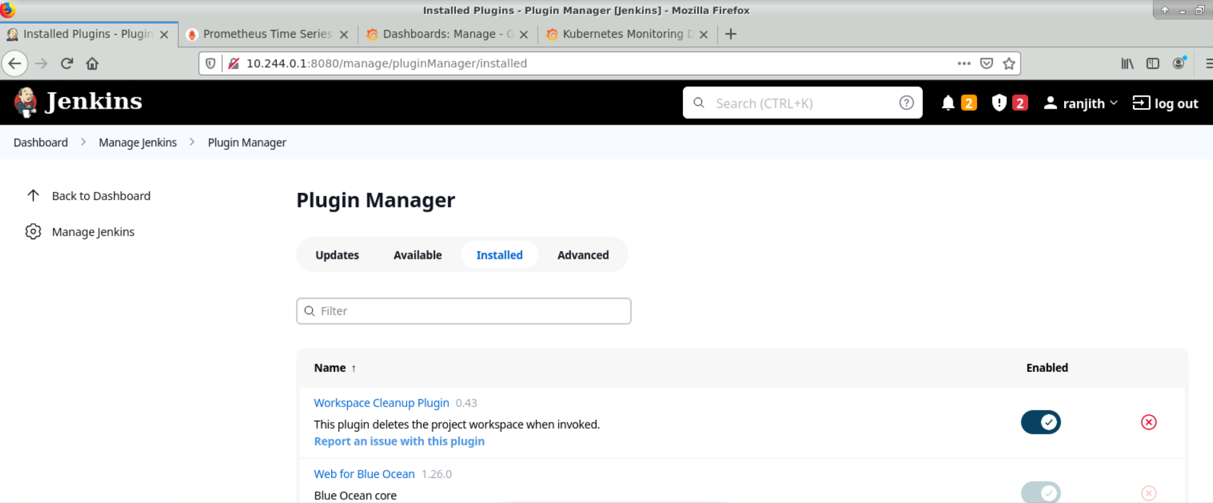
8. Navigation: Dashboard >Manage Jenkins >Nodes
9. 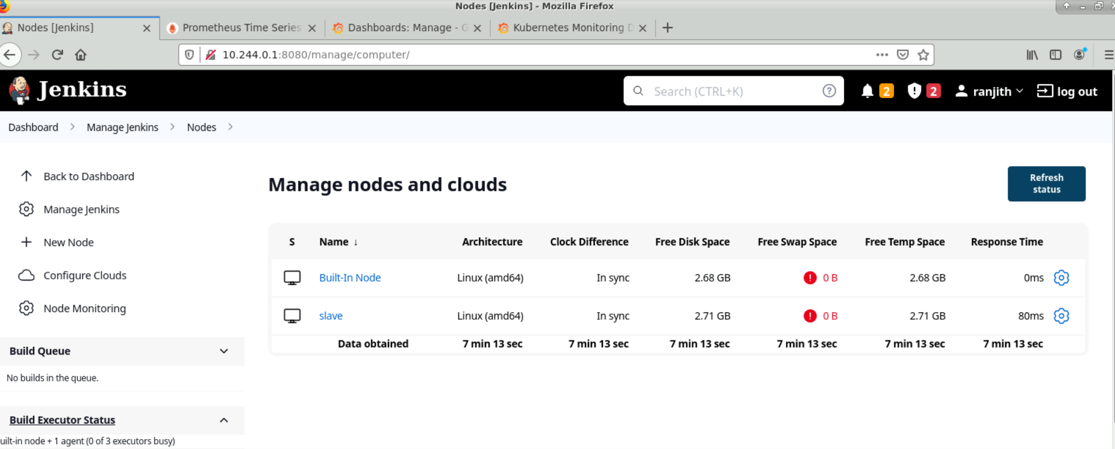
10. Setup Master-Slave architecture on Jenkins
11. Used Freestyle project to create CI and CD pipeline.
12. 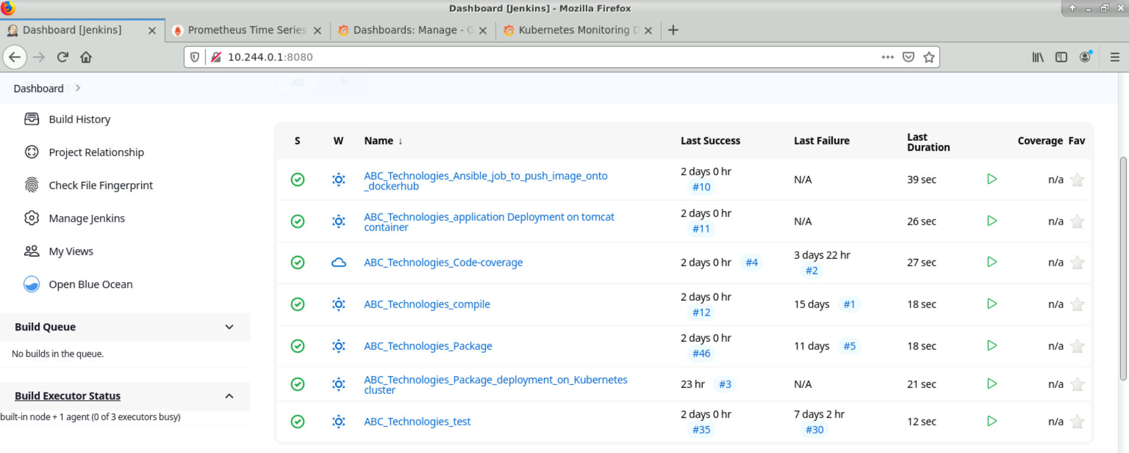
13. I have given upstream and downstream to the jobs which are dependent to create a pipeline.
14. 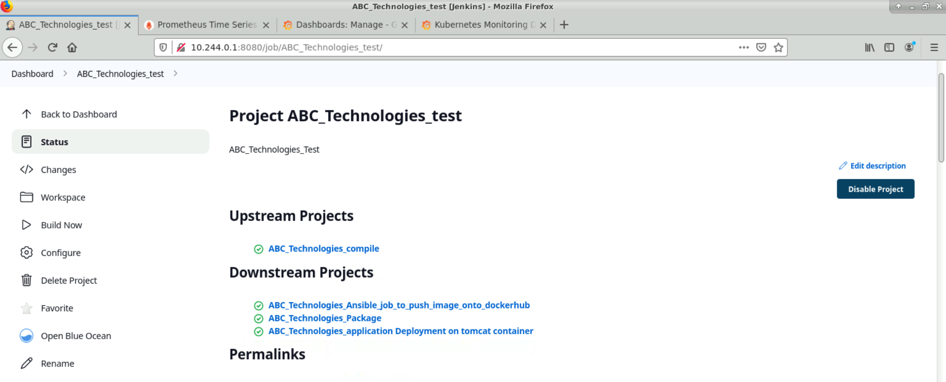

**Jobs:**

**Compile job:**

1. 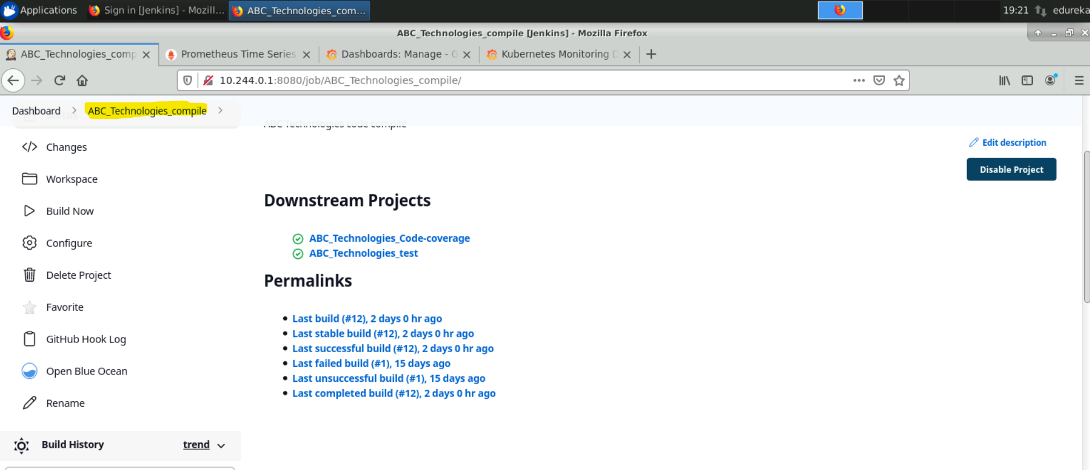
2. In configuration
3. 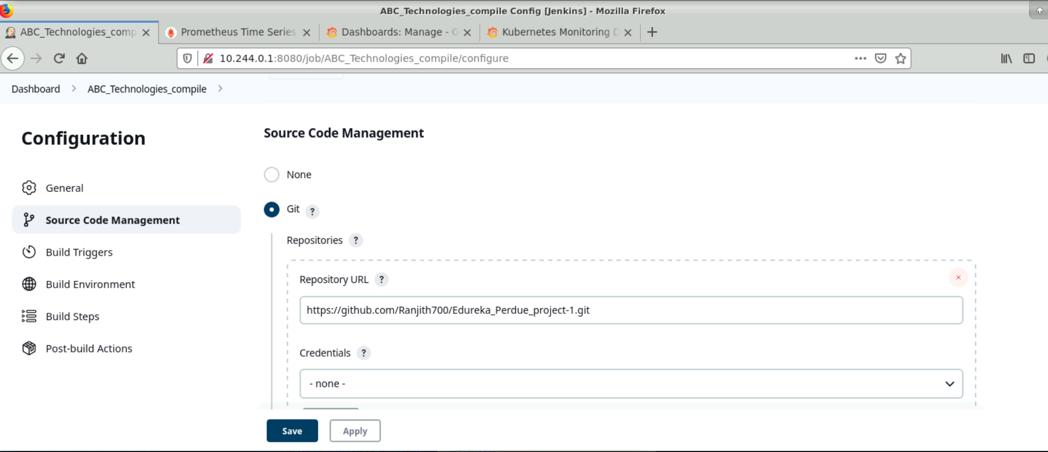
4. I have given my Git repo link and it is a public repo.
5. In Build triggers I have chosen Github hook trigger for GitSCM Polling. It will trigger the job if any thing is pushed and commited to our Github repo.
6. 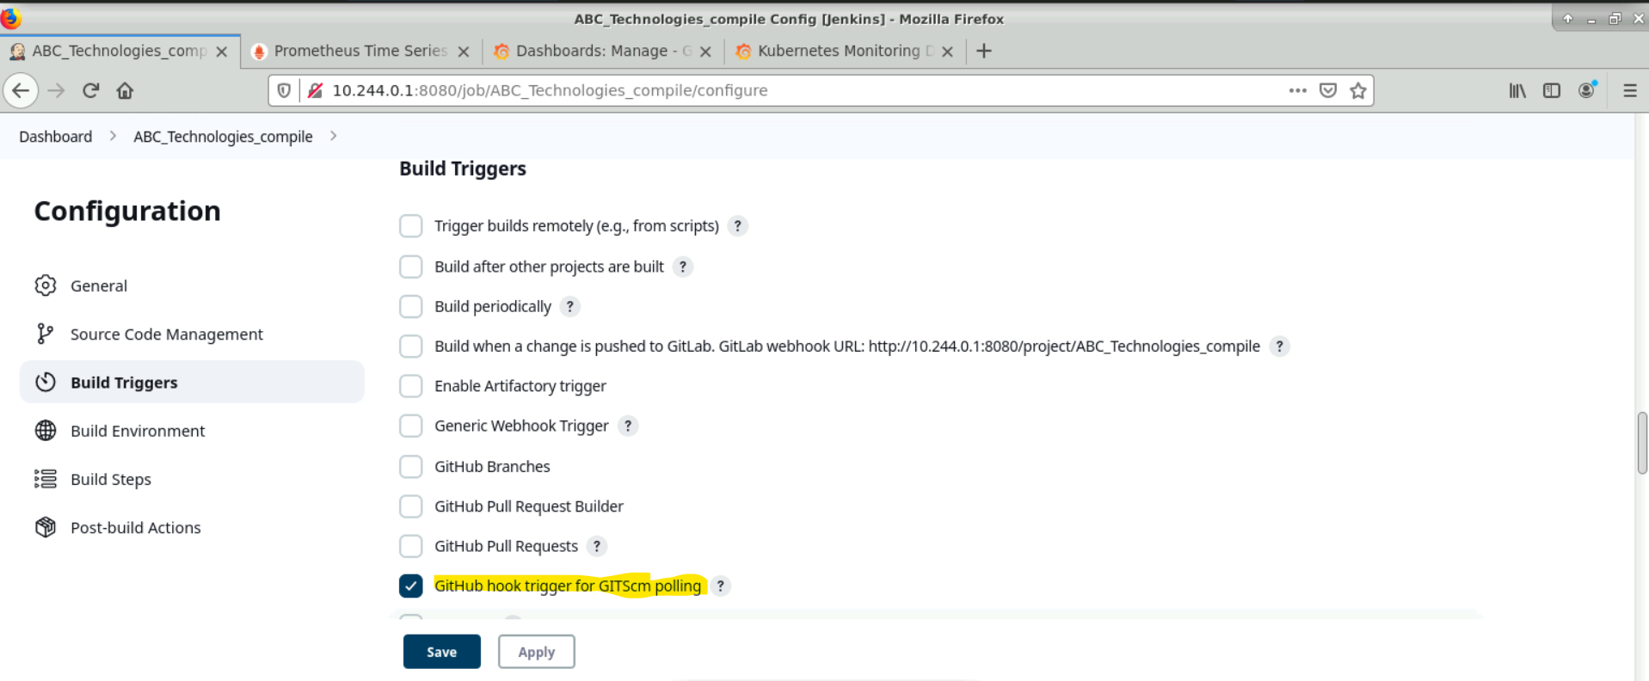
7. We can set Github hook by adding our payload URL/github-webhook/ in setting of webhooks in Github
8. ****And I have given this webhook trigger only for this compile Job. Later on Jobs are triggered from Compile job****
9. 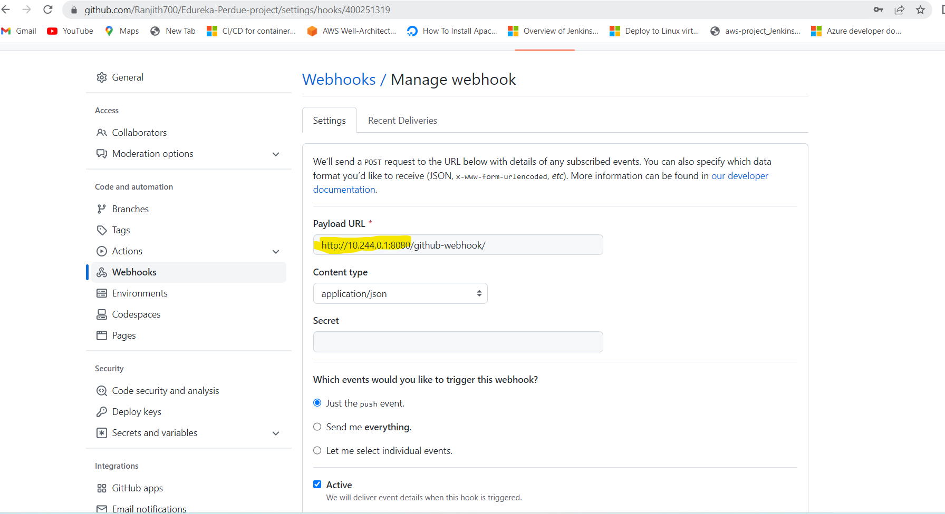
10. As we have given our remote repo link , Jenkins will pull the pom.xml data from there .

**Build step:**

1. I have given Maven path as M2_HOME(Given path in configurations) and goal as compile here .
2. 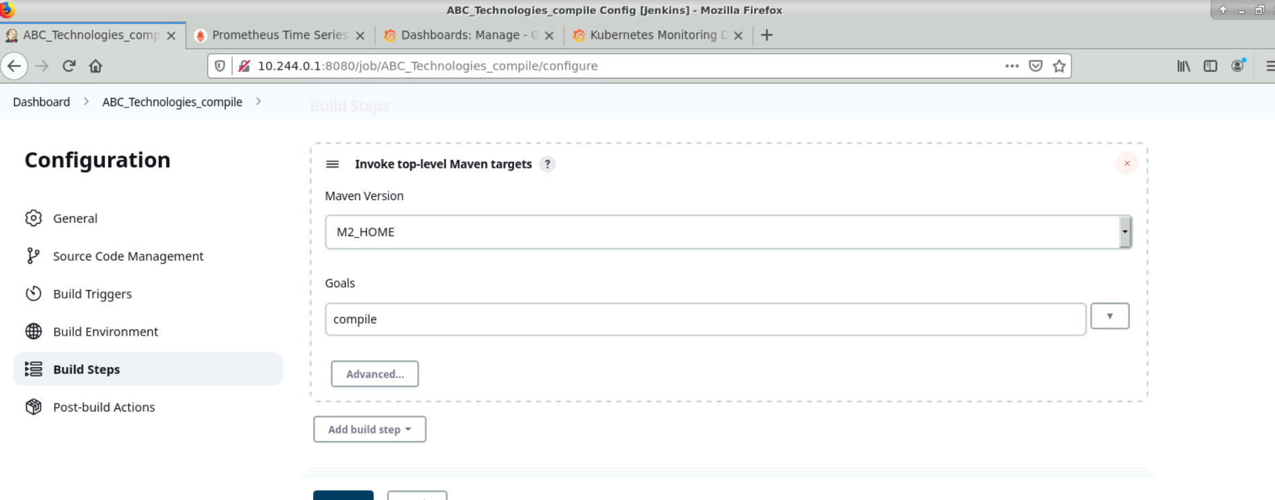
3. Output:
4. 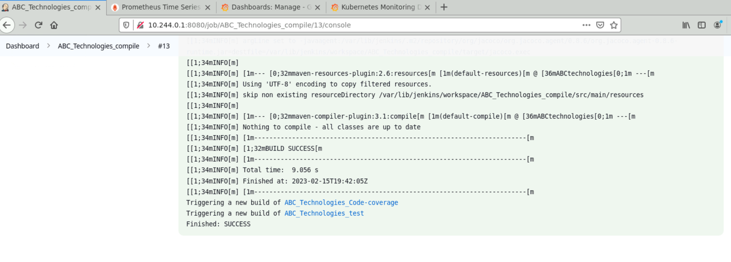
5. In the same way I have Configured Jobs for Test , Code Coverage and Package .

**Test Job:**

Here goal is clean test

1. 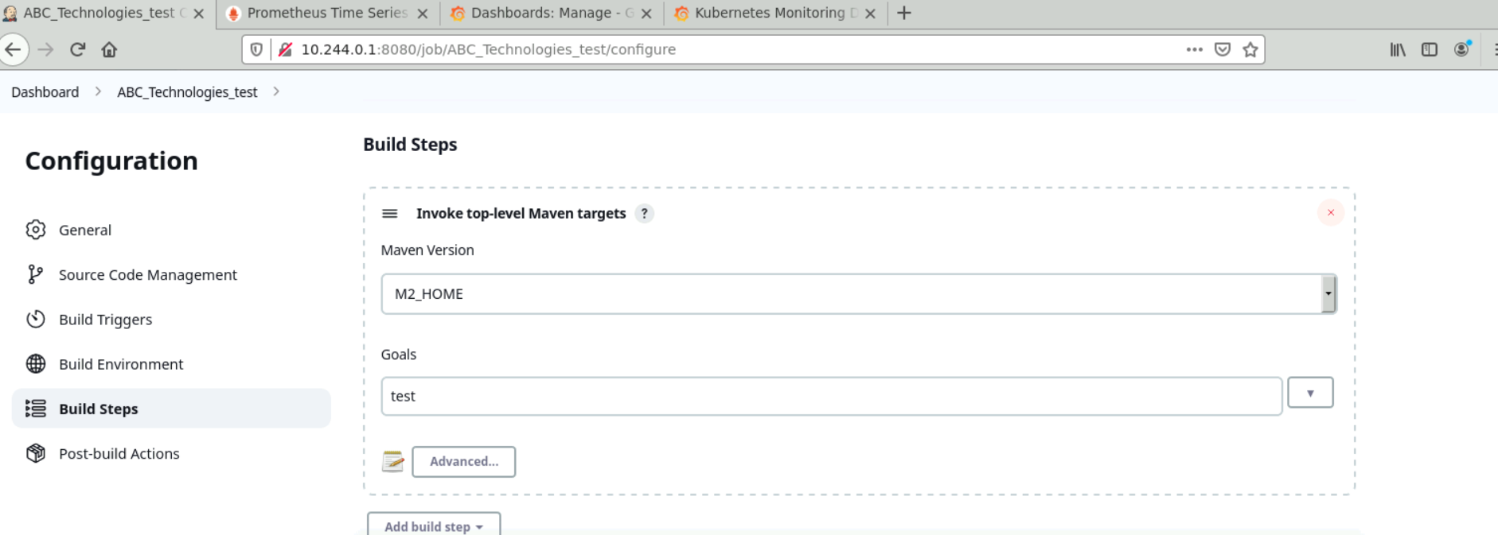
2. Output :
3. 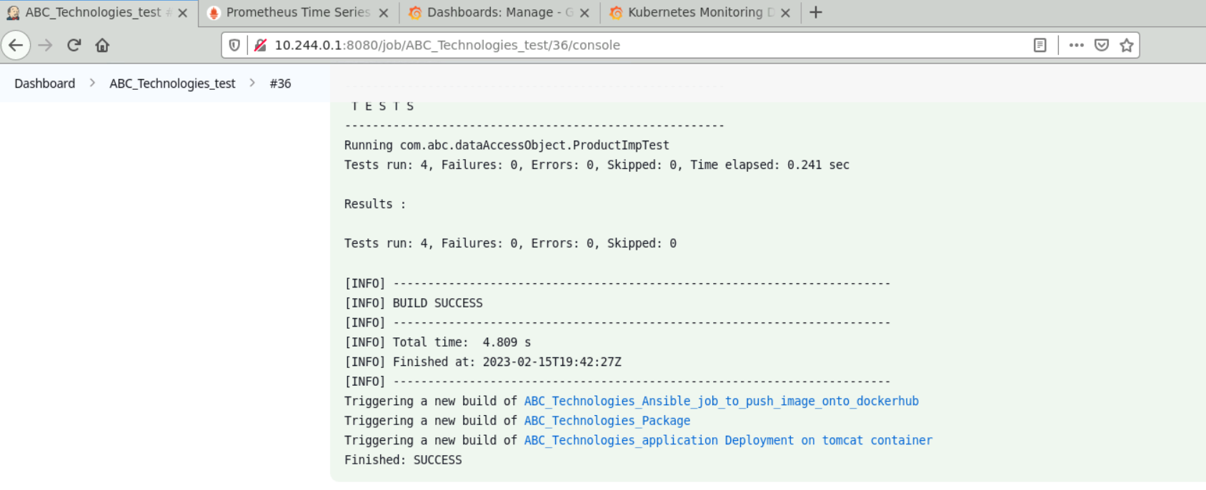

**Code Coverage:**

1. 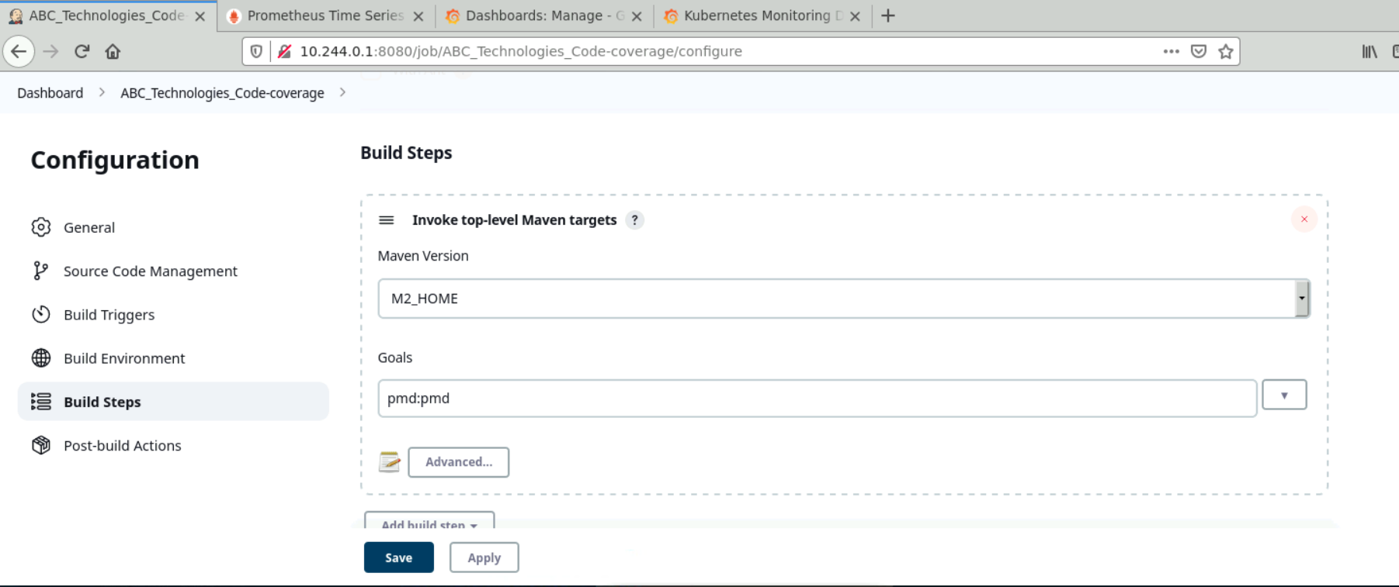
2. **Output:**
3. 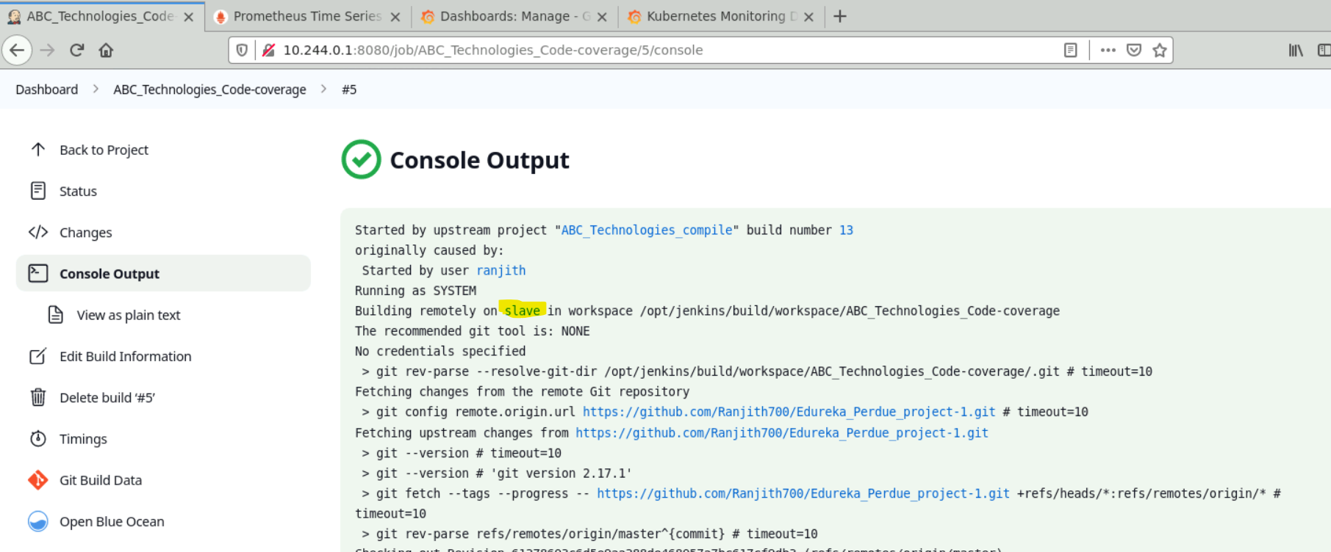
4. This Job got executed in Slave node.

**Package Job:**

1. 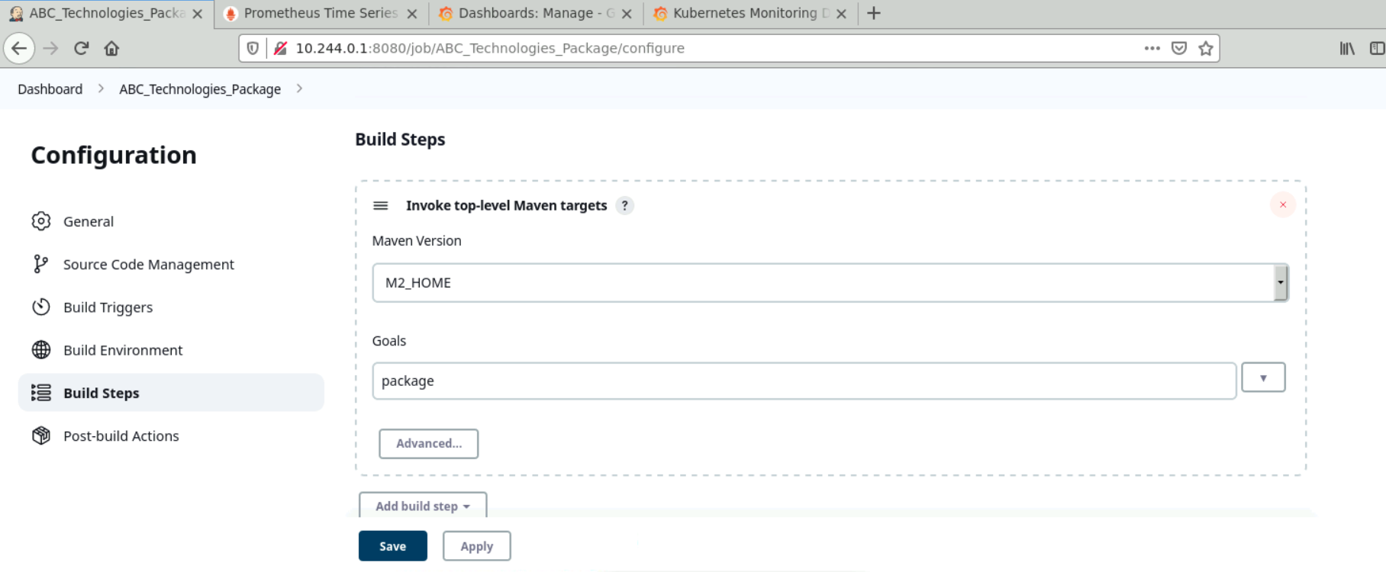
2. **Output:**
3. 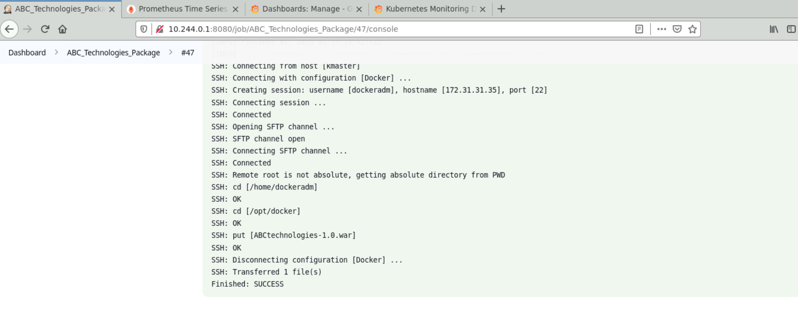
4. As I have given upstream and downstream to these jobs , once any commit is pushed to the GitHub repo ,webhook will trigger the compile job and later compile job will trigger test and package respectively according to the stream .This acts a pipeline .

## Task 3: Deployment with Docker

**Docker:** Docker is a set of platforms as a service product that use OS-level virtualization to deliver software in packages called containers. The service has both free and premium tiers. The software that hosts the containers is called Docker Engine.

**Tomcat:** Apache Tomcat is a free and open-source implementation of the Jakarta Servlet, Jakarta Expression Language, and WebSocket technologies. It provides a "pure Java" HTTP web server environment in which Java code can also run. Thus, it's a Java web application server, although not a full JEE application server. Here I’m using Tomcat container to deploy our /.war file.

**Task 3:** Write a Docker file. Create an Image and container on the Docker host. Integrate docker host with Jenkins. Create CI/CD job on Jenkins to build and deploy on a container.

1. Created a dockeradm user on Slave-node and added it to docker group in Slave-node.
2. Added this dockeradm user credentials with server details(Docker) in Jenkins as below.
3. 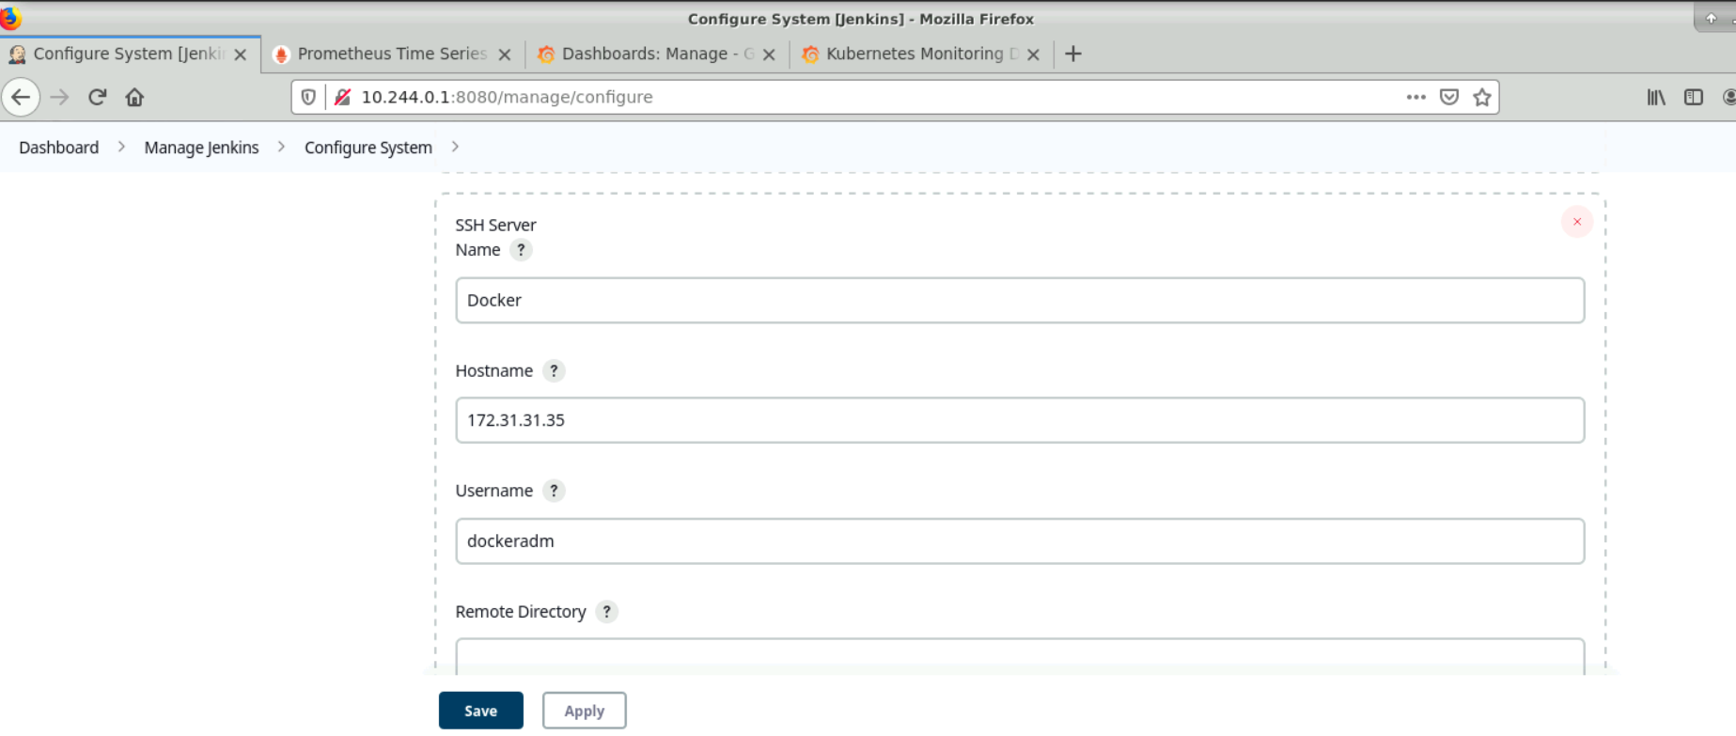
4. From Package job , moving the .war file from target folder to docker workspace folder (/opt/docker) in Slave-node.
5. 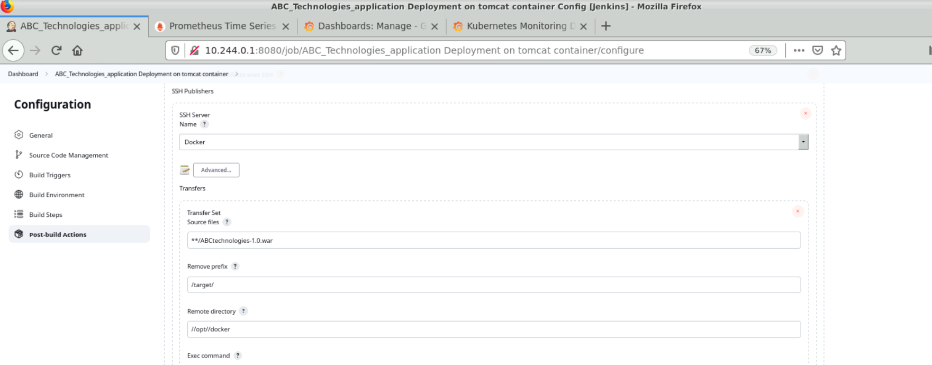
6. Created a Dockerfile in /opt/docker/ of Slave-node.
7. 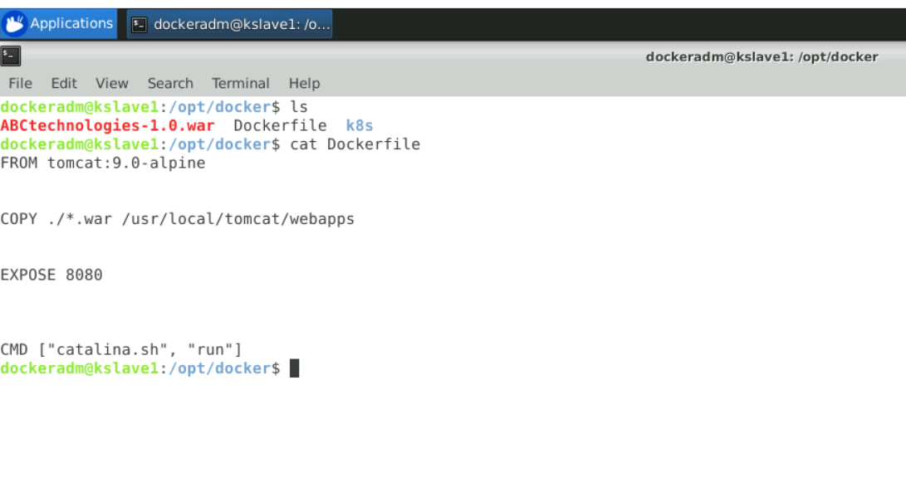
8. In the Dockerfile, I have used tomcat: 9.0-alpine as base image and moved /*.war file to webapps folder of tomcat container, expose it to internet and started the tomcat services.
9. In Exec Command, I have given below commands to remove any existing containers with same name and build a new image **(tomy:v1)** once a new package is build every time.
10. 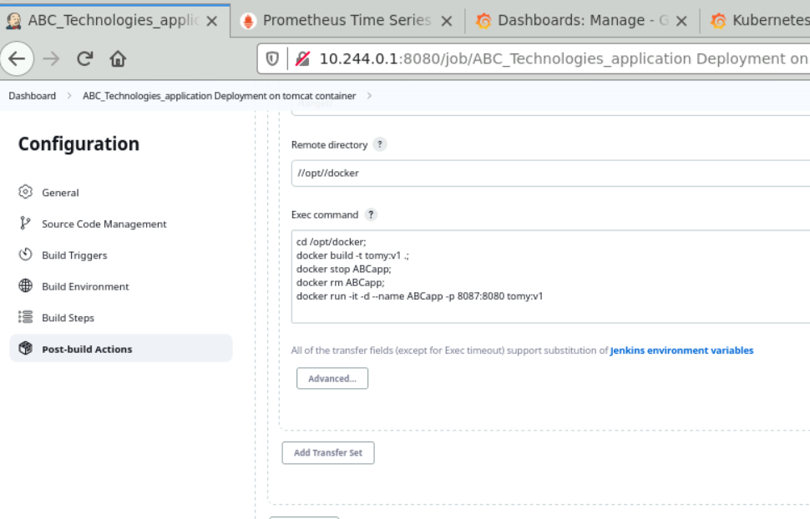
11. Output:
12. 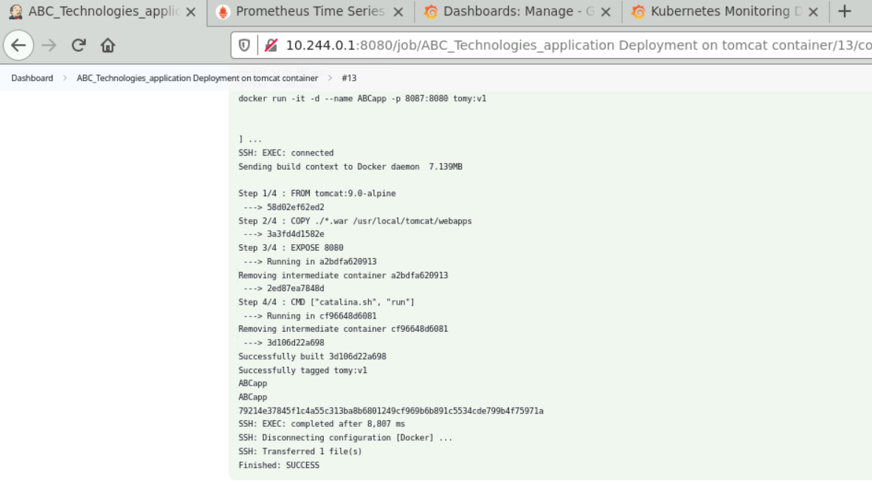
13. Tomcat container is deployed as below and exposed to internet with our package /*.war file.
14. 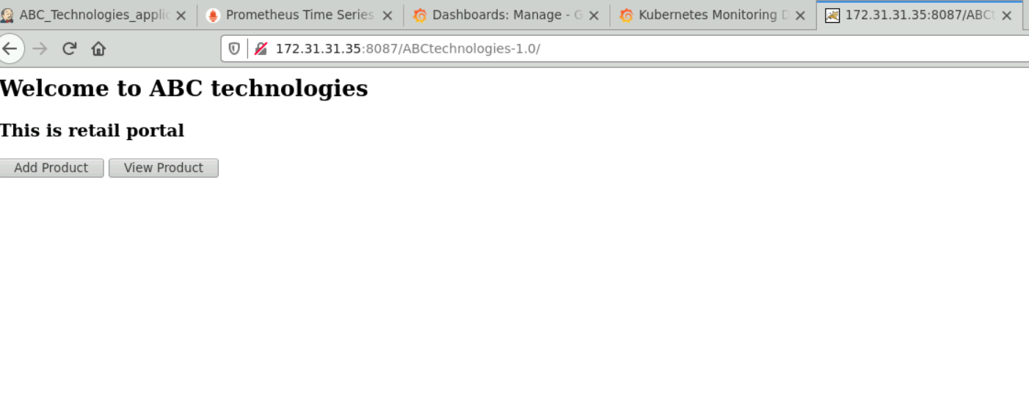
15. We can access the container using : <http://172.31.31.35:8087/ABCtechnologies-1.0/>
16. Created the jenkins pipeline by adding this job as downstream to package job. Once any new package is build a new Image is built over docker host and build the required container with /*.war file in it.

## Task 4: CD using Ansible, Docker & Kubernetes

**Ansible:** Ansible is an open-source IT automation engine that automates provisioning, configuration management, application deployment, orchestration, and many other IT processes.

**Kubernetes:** Kubernetes is an open-source container orchestration system for automating software deployment, scaling, and management. Google originally designed Kubernetes, but the Cloud Native Computing Foundation now maintains the project.

**Task 4:** Integrate the Docker host with Ansible. Write an Ansible playbook to create an image and create a container. Integrate Ansible with Jenkins. Deploy Ansible-playbook. CI/CD job to build code on ansible and deploy it on docker container.

1. Using edureka user on Master-node and added playbook for creating & pushing docker image to dockerhub.
2. 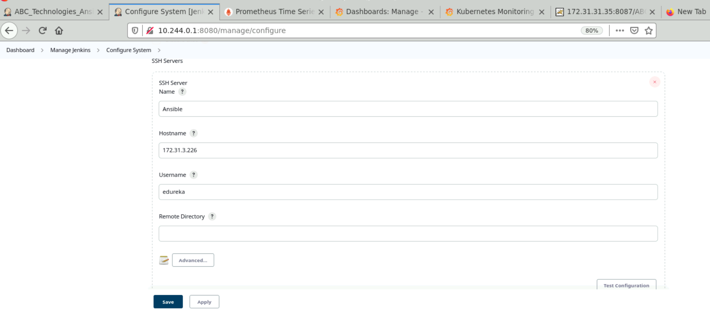
3. Used Package job as upstream to configure this job.
4. Moved the /*.war package to /opt/ansible in work directory.
5. 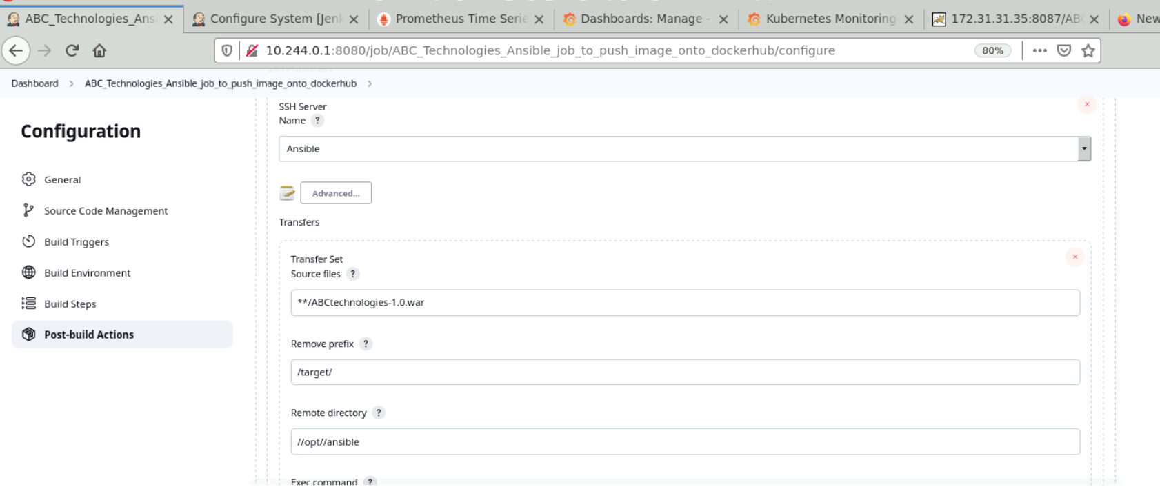
6. 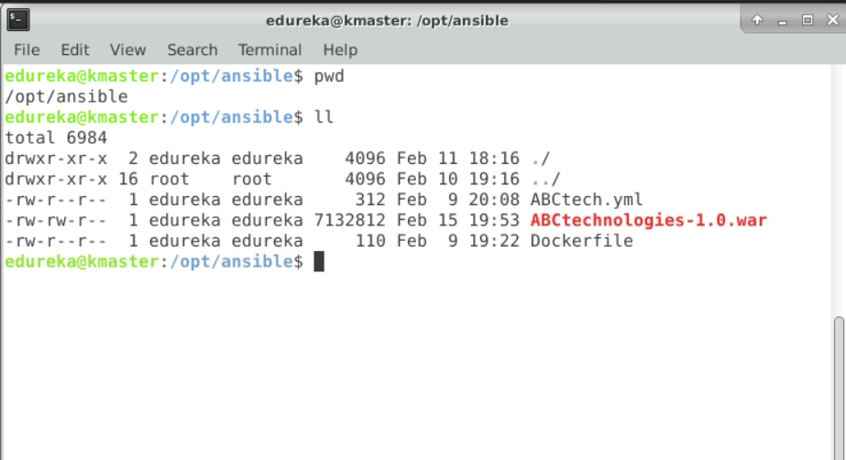
7. Created the Dockerfile to create an Image with /*.war package in it and run on tomcat container.
8. 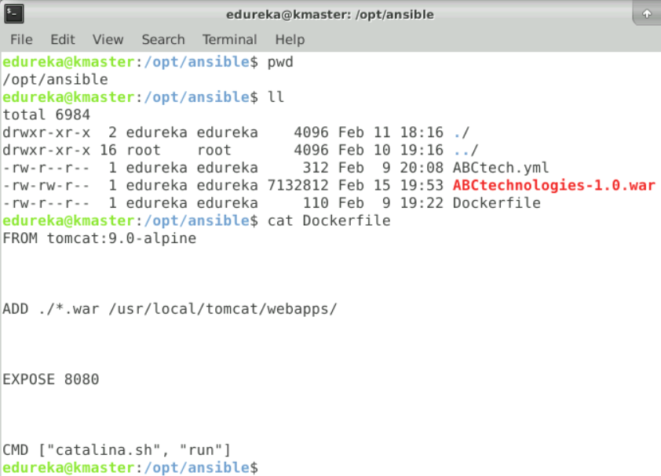
9. Added Ansible Playbook to create and push docker Image to docker hub.
10. 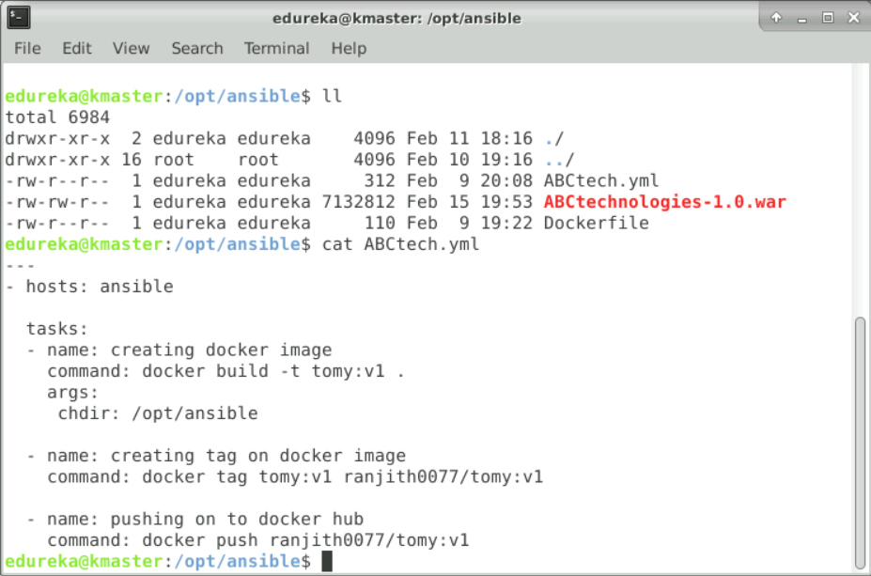
11. In Jenkins Job, I have given commands to execute this ansible playbook only after Package job executed successfully.
12. 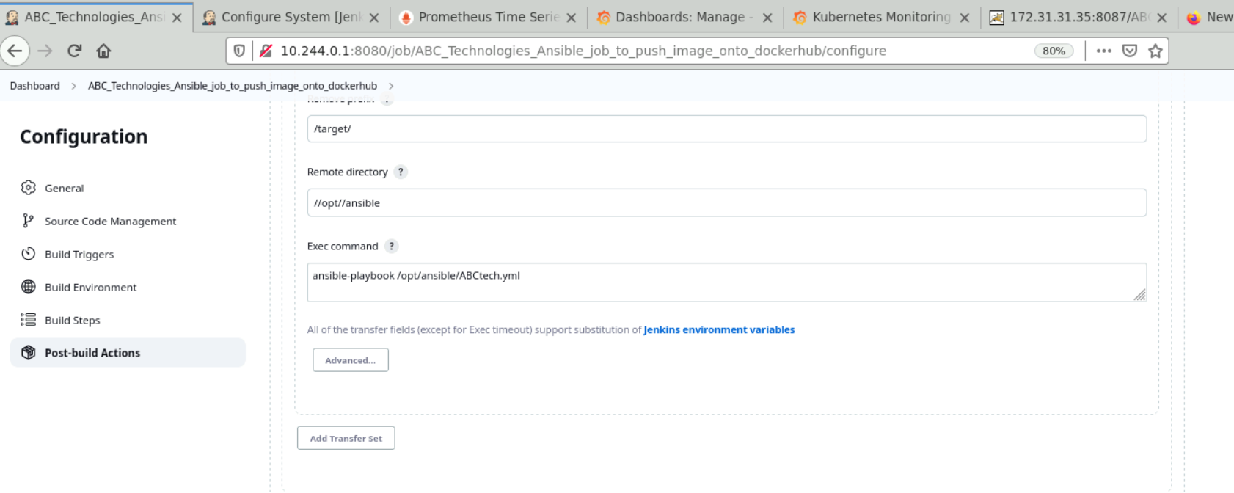
13. Output:
14. 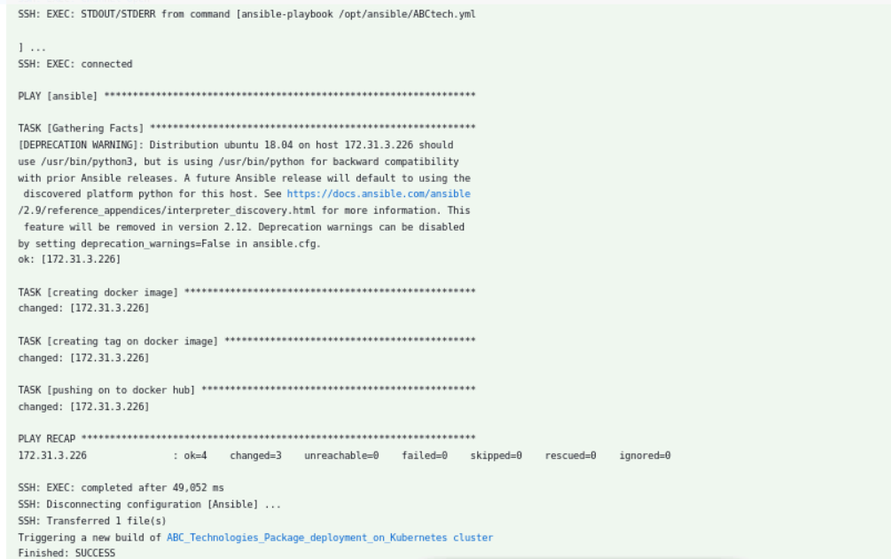
15. 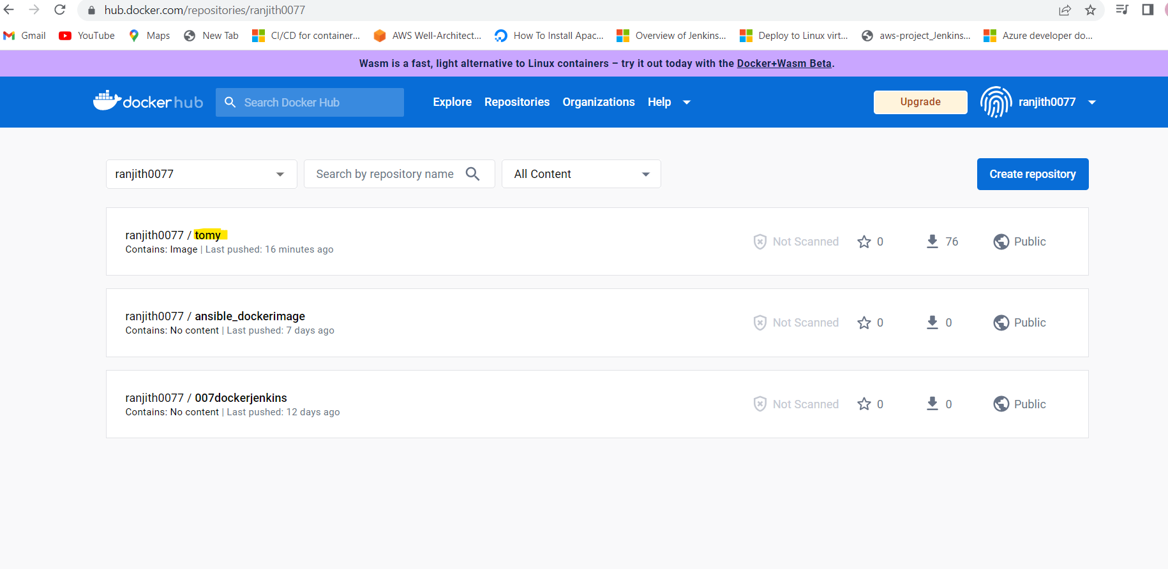
16. Using Ansible, I have created the docker Image with /*.war in it and pushed to dockerhub.
17. Created Kubernetes service and deployment manifest files in /opt/k8s work directory.
18. 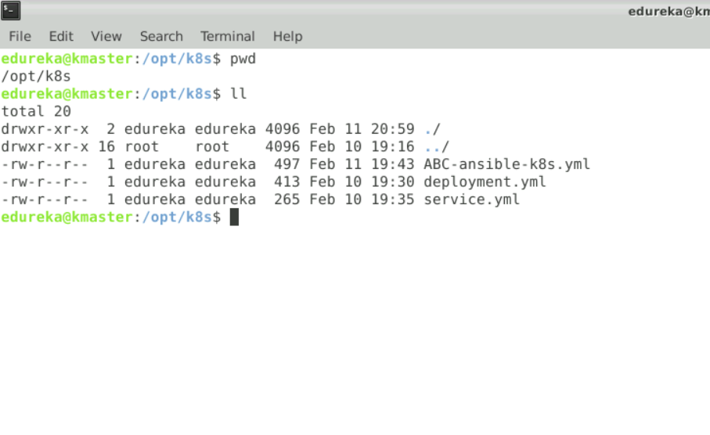
19. 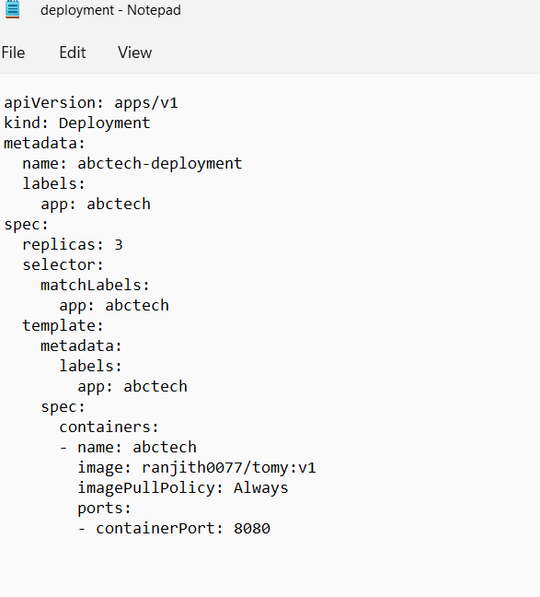
20. 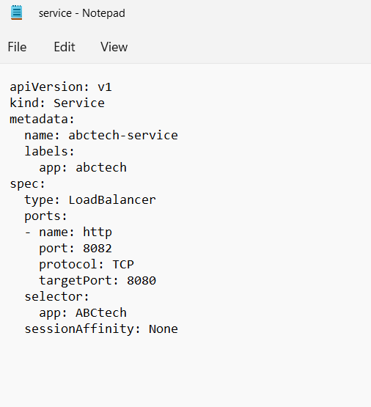
21. Created ansible playbook to deploy Kubernetes resources
22. 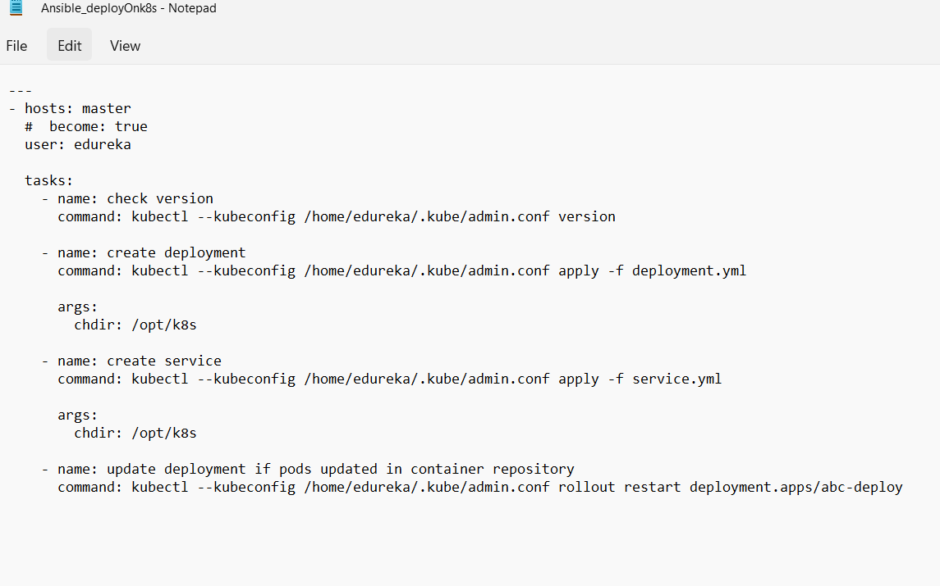
23. Created Jenkins job to automate the execution of the playbooks to achieve continuous deployment using (ABC_Technologies_Ansible_job_to_push_image_onto_dockerhub) as upstream.
24. Execute ansible-playbook to deploy on K8’s Cluster only if upstream job is stable.
25. 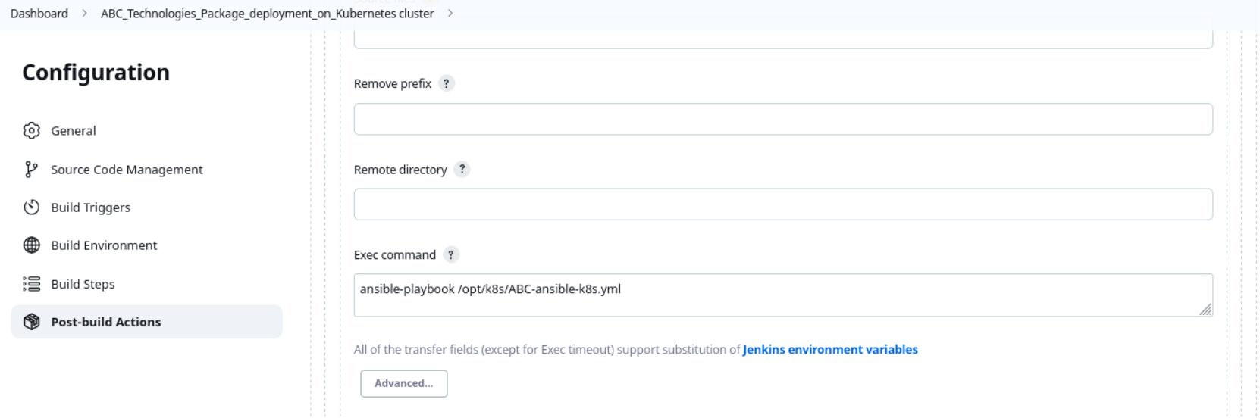
26. Output:
27. 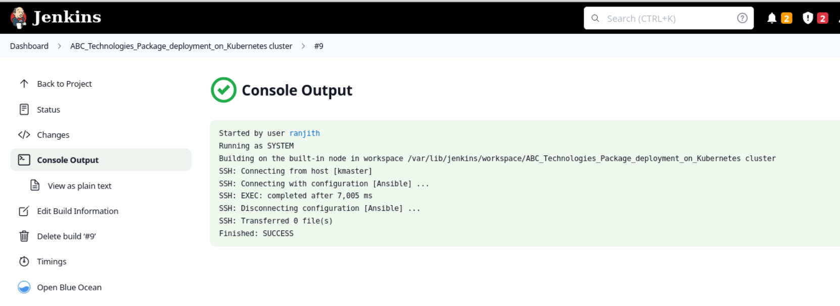
28. 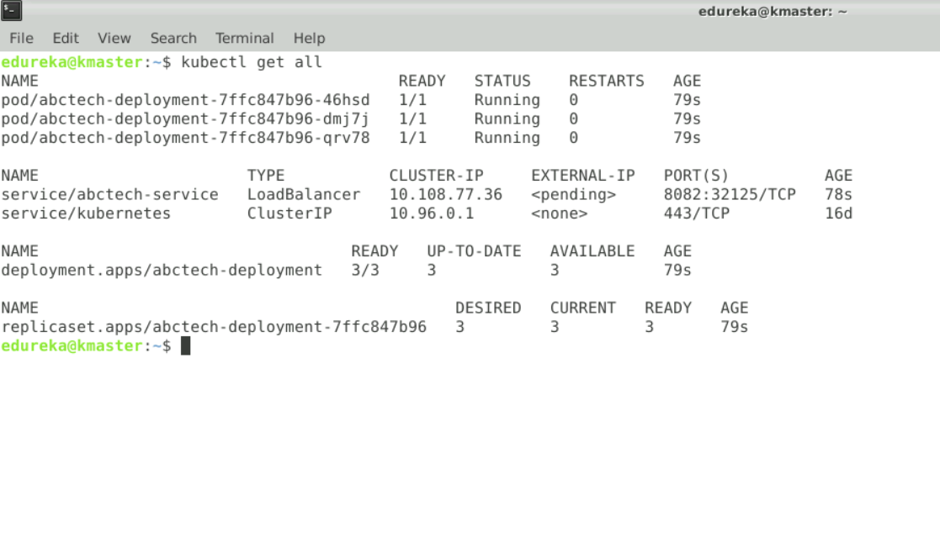
29. 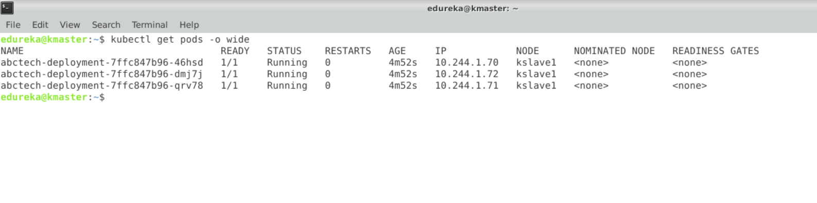
30. 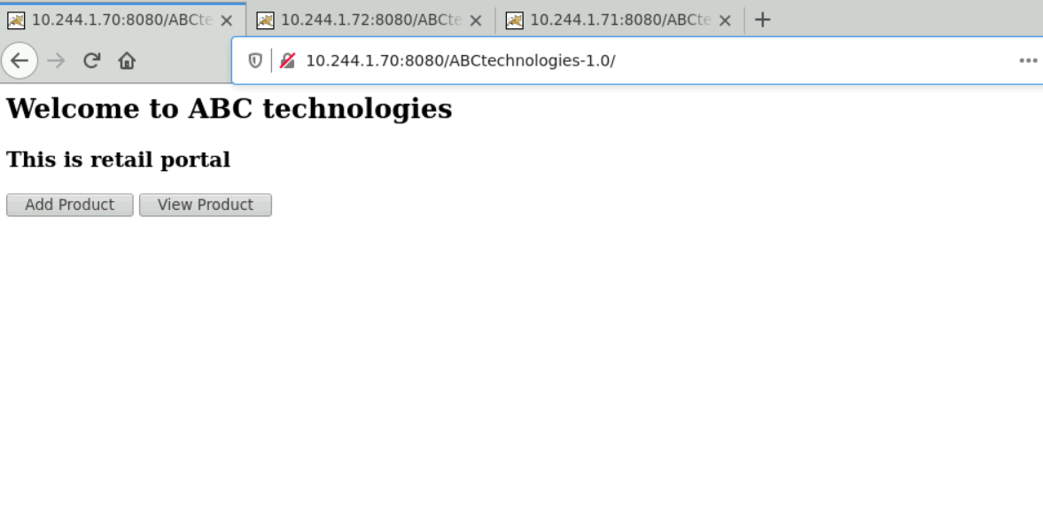
31. 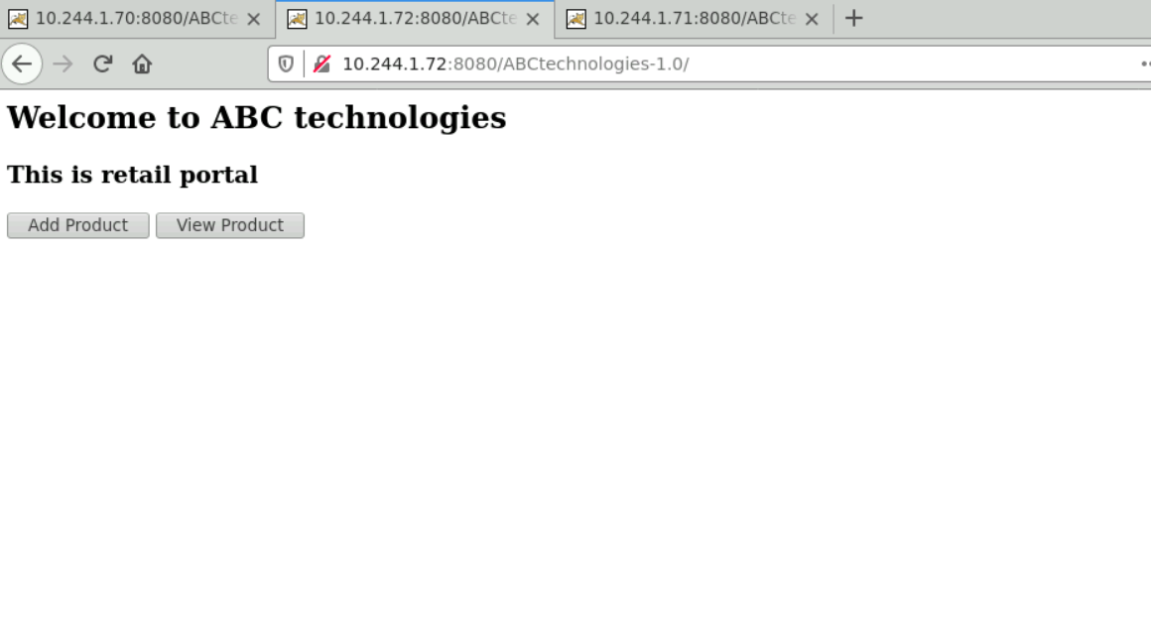
32. 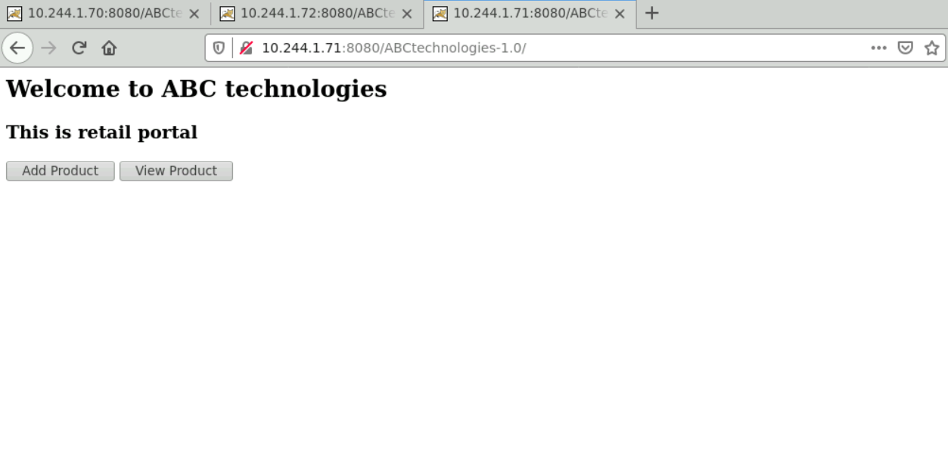

***Kubernetes cluster is up and running with our deployed /*.war file***

## Task 5: Monitoring using Prometheus and Grafana

**Prometheus:** An open-source monitoring system with a dimensional data model, flexible query language, efficient time series database and modern alerting approach.

**Grafana:** Grafana is a multi-platform open-source analytics and interactive visualization web application. It provides charts, graphs, and alerts for the web when connected to supported data sources

1. Installed node exporter for linux from prometheus web page.
2. 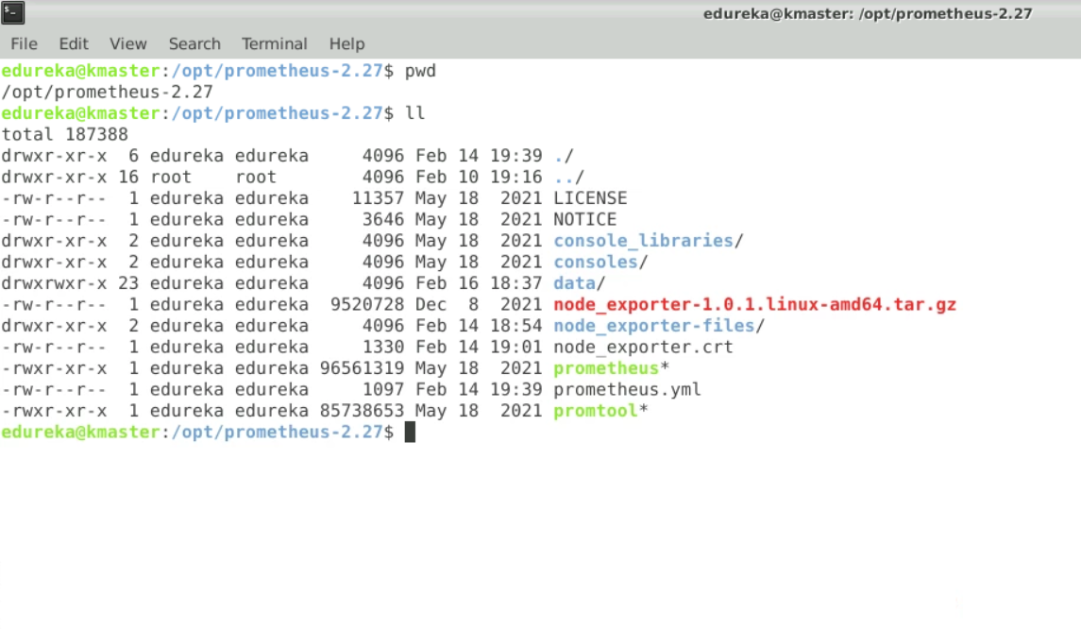
3. Renamed the extracted tar file to node_exporter-files.
4. 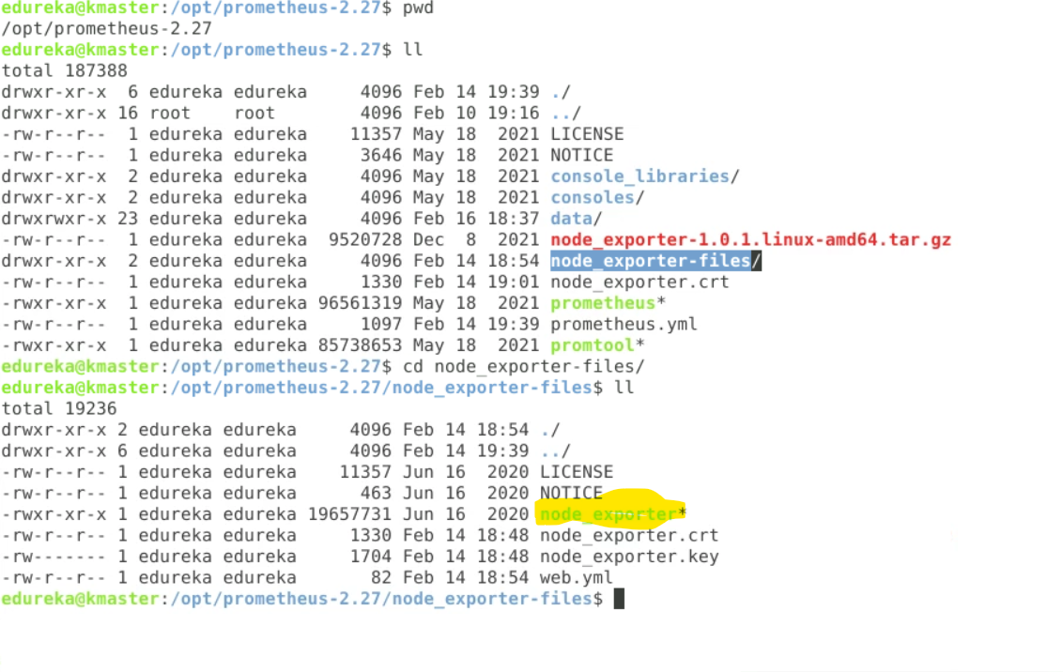
5. Ran the node_exporter script.
6. Added the node_exporter target to the prometheus.yaml file.
7. 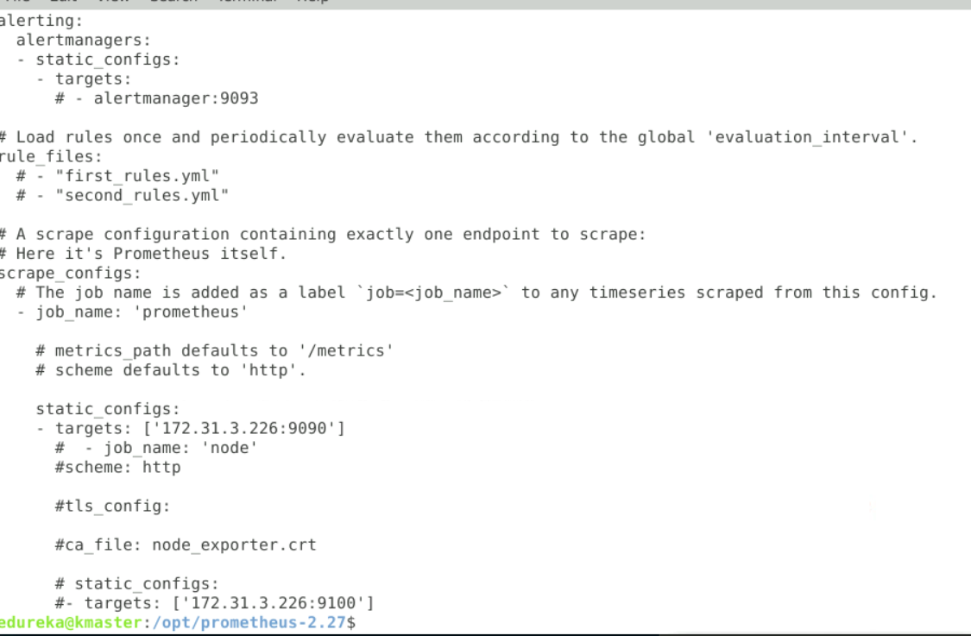
8. Created Grafana dashboard.
9. Added the source as Prometheus.
10. Output:
11. 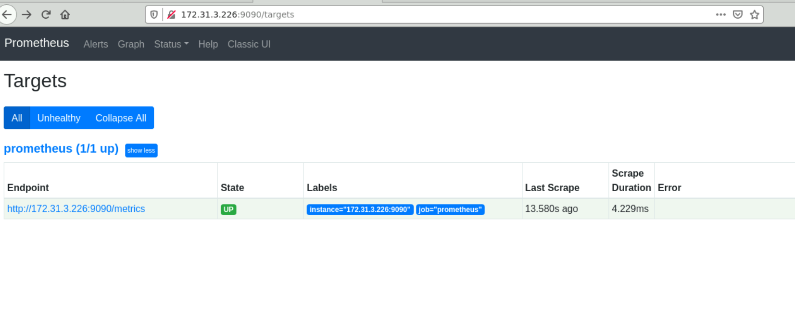
12. 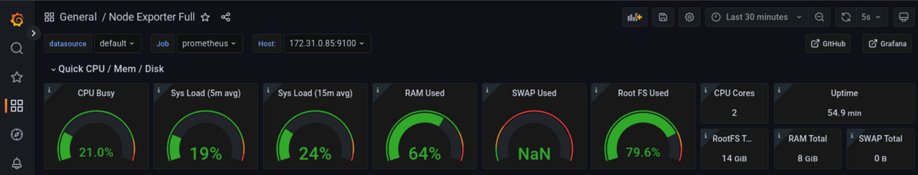
13. 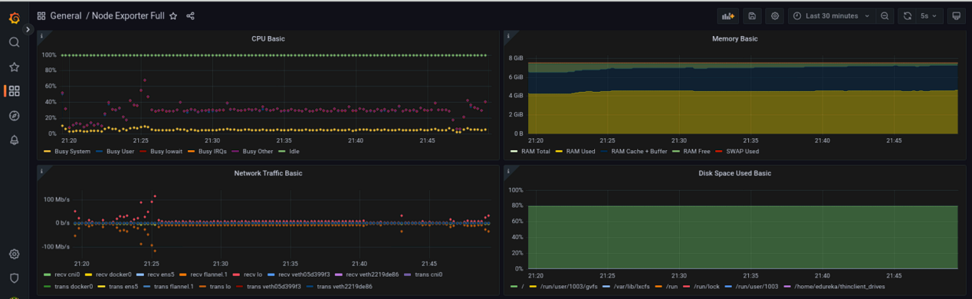

***End of the Project ***